***NOTES:***

*Every Affiliate has a different run schedule; please feel free to customize any of the emails below and/or the order etc. You know your list better than we do.*

*In this document you’ll find:*

1. *Standard promo emails*

*Two “dealers choice” options…*

1. *“Blueprint” promotional emails that can be used in conjunction with the standard emails (this may take some extra setup on your part) as it requires you to setup a process to send registrants a blueprint after they’ve attended. We can help you on this if needed. Contact us for the blueprint image if you want to use these.*
2. *A follow-up FAQ email for Attendee non-buyers.*

Our best converting registration page is (feel free to swipe from it as you see fit): <https://www.realestatewealthnetwork.com/training/>

**===============  
Standard Emails**

**===============**

**Email #1**

**Subj:**

20 types of motivated sellers (BRAND NEW)

Find the “super buyers” in your market

Golden opportunities

**Body:**

Hey {FIRSTNAME},

How many deals do you want to do this month?

…3?

…5?

…10?

Tonight I’ve arranged a very special guest to come on and share his brand new intelligence-based investing system that allows you to easily identify all the ultra-motivated prospects for doing more deals that your heart (and bank account) desires.

>> Click here to get started now!

Join us above and see how **without leaving your desk** you can filter through the junk and **find an abundance of golden opportunities** your competition can’t touch, plus you’ll learn how to…

Get access to 20 different types of motivated sellers within your market…

Identify the “super buyers” in any market (get their contact info & phone numbers) and even do advanced research to see what they’ve already bought and where so you can deliver deals to them on a silver platter…

Get $1,000,000 for your deals (without bank qualifying or credit)…

And more!

Hurry over now – we’re starting soon!

Regards,

{AFF NAME}

**P.S. The real estate investing game has changed.** Truth is, it’s always changing. Join us tonight and learn how savvy investors are moving forward and finding success in our current market. >> Click here now! <<

**Email #2**

**Subj:**

List of “specialty leads” (ultra-motivated sellers)

List of “specialty leads” with multiple levels of motivation

List of “specialty leads” NOT on the MLS

Get “specialty leads” BEFORE the MLS

**Body:**

Hey {FIRSTNAME},

How many more deals would you be able to do if…

1. You had the ability to access **multiple lists of specialty leads** (ultra-motivated sellers) that your competition can’t touch.

2. You got access to them **BEFORE they hit the MLS!**

3. You could target **leads with multiple motivations**, this is called   
“motivation stacking”, and get to them (the best deals) first!

…Well now you have the ability to do all that and MUCH More!

>> Click here to join us for today’s FREE webinar training & I’ll show you how to get started immediately!

Regards,

{AFF NAME}

P.S. It took my special guest TWO years (filled with rigorous tweaking and beta testing) to get this right. Now you can use this ground breaking new system to do more deals and cash more checks fast!

>> Click here now!

**Email #3**

**Subj:**

We’re starting NOW!

**Body:**

Hey {FIRSTNAME},

I’m going to make this really quick because...

We’re about to jump on a webinar and break down THE system for EXACTLY what you need to be successful in real estate in 2020.

>> Click here to join me!

…you need to **hurry** because we start soon!

Here’s what we’re about to cover…

* A tool you can use to quickly identify over **20 key motivational types** and find the **ultra-motivated sellers** through our proprietary “Stacking Method” in every market!
* How to leverage this **NEW intelligence-based technology** to work smarter (not harder)!
* How to get access to $1,000,000 **(you read that right, 1 million)** to fund an unlimited number of your deals *and we’ll explain why and how my special guest can do this and still stay in business.*
* A push button process for finding buyers who are flush with cash and how to identify the “super buyers” in any market!
* How to put the **3 fundamental tools** and the **3 necessities** a successful investor needs together (I call this the Real Estate Trifecta), because **when you do…the payout is HUGE!!**

Be one of the FIRST to access this brand new training below and blow your competition away!

>> Click here to join us now!

Regards,

{AFF NAME}

**Email #4**

**Subj:**

Open Saturday (this expires) *\*\*Replace day with day you send on\*\**

Screenshots of NEW system (this is killer)

**Body:**

Hey {FIRSTNAME},

Hopefully you get this email in time.

I’m hosting a very special training today where you’ll learn how to follow three simple steps cashing your next check in any market across the country!

>> Click here and join me now!

First you’ll see **how to easily find & contact sellers** with the click of a button…

*(There are literally millions of motivated sellers here)*

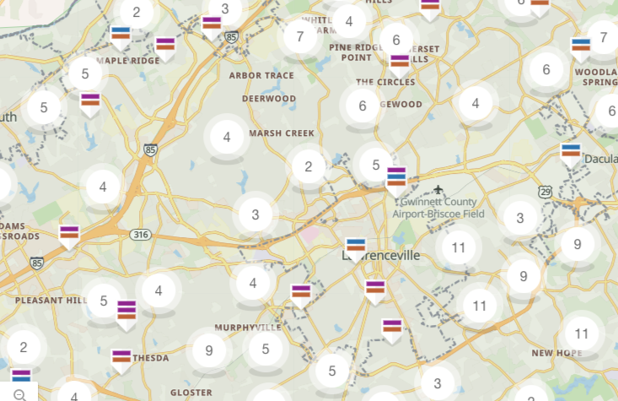

Then we’ll show you how to **flip those deals to one of the many “super buyers”** in your market…

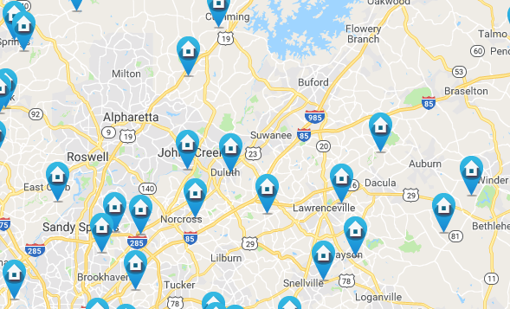

And then, **how to get access to and use $1,000,000 of my special guests money to fund your deals** if you need it (no qualifying, no credit checks, etc…and no fee’s!)

See just 4 of our recent screen shots from our funding log below…



(this should be a moving GIF…if it’s not email Josh)  
Josh@RealEstateWealthNetwork.com

>> Click here to choose the time that works best for you!

Regards,

{AFF NAME}

**Email #5**

**Subj:**

The power of THREE (OPEN NOW)

The power of THREE

The power of THREE – The REI Trifecta

**Body:**

If you haven’t already heard…

A friend of mine JUST released an all-new system called the **REI Trifecta.**

He calls it that because it gives you everything you need to do more deals and WIN BIG, including…

**1. Motivated sellers** (over 20 different types so you’re always flush with good leads)

**2. Cash buyers** (with advanced buyer-intelligence that ensures you sell fast)

**3. $1,000,000 in funding for your deals** (on an unlimited # of deals)

These 3 fundamental components give everything you need to get the deals done and put more money in your pocket!

**For some of you…that’s all you need.** You’re looking for real, tangible opportunities to do deals and those three tools above (sellers, buyers, funding) are the missing pieces! (Click here to learn how to get started fast!)

**…but for others there’s still a few things missing**… and that’s why those 3 components are just the tip of the iceberg.

>> Click here to join me tonight and learn more!

**This training is FREE**…and if you’re HUNGRY for more this year you owe it yourself to hear and SEE what we’re am about to share.

Regards,

{AFF NAME}

**Email #6**

**Subj:**

Open if you like RESULTS

**Body:**

Hey {fname},

There’s been **a ton of buzz going around** about my friends brand new REI Trifecta system the last week or so.

And for good reason... he’s gone above and beyond with this one...included everything you need to succeed and then some.

**...but none of that is as important as RESULTS**. That’s why today I’m excited to share with you how students like....

Ronnie from Nashville **made $58,101**....

Will from Texas **made $10,146**....

Debra from Pennsylvania **made $41,000**…

And Mark from Illinois **made $43,247**….

>> Click here to join us and see how you can start doing more deals now!

*Of course, I can’t sit here and tell you that results are guaranteed. Heck, I wouldn’t even presume to know if you’re the type of person that’s willing to roll up your sleeves and take action.*

...but what I can say is that this system includes all the tools, resources, training and support any investor needs to create a real, sustainable business.

**I wish I would’ve had this system when I was getting started!**

>> Click here to join us now!

If you’ve been sitting on the sidelines looking for something REAL, then I urge you to join me on this special call now.

The only difference between those doing deals, like the students I mentioned above, and those that aren’t are a few very specific actions!

>> Hurry over and reserve your spot for this free training now!

Regards,

{AFF NAME}

**Email #7**

**Subj:**

Neighborhood watch

**Body:**

Hey {frName},

How would you like to be the first person notified when killer deals become available in your area?

…I’m talking all the way down to specific neighborhoods, like this…

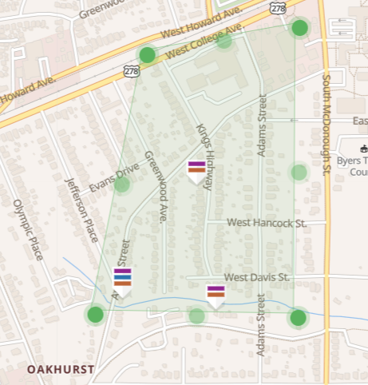

Or even specific roads…

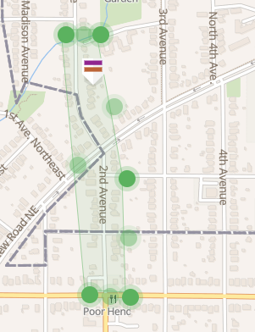

**GOOD NEWS:** Using this brand new system you can now dominate your market and set ALERTS so that you’re notified instantly when super motivated sellers hit the system (join us below and we’ll show you how)!

>> Work smarter, not harder with this intelligence-based system & start doing more deals now!

Now, **without leaving your desk** you can filter through the clutter and **find an abundance of golden opportunities** you competition can’t touch, plus you’ll learn how to…

Get access to 20 different types of motivated sellers within your market…

Identify the “super buyers” in any market (get their contact info & phone numbers) and even do advanced research to see what they’ve already bought and where so you can deliver deals to them on a silver platter…

Get $1,000,000 for your deals (without bank qualifying or credit)…

And more!

Hurry over now – we’re starting soon!

Regards,

{AFF NAME}

**Email #8**

**Subj:**

Motivation stacking = MIND BLOWN!

**Body:**

Hey {frName},

One of the powerful built-in tools in this new system is the ability to use **“Motivational Stacking**” to target the VERY best leads in your area or all across the country.

>> *Join us now and we’ll show you how it works!* *(This is a free training)*

**Here’s a taste of what Motivational Stacking can do for you...**

Instead of just targeting absentee owners, vacant owners, folks facing foreclosures, etc. You can now “STACK” multiple levels of motivation on top of one another and combine it with advanced property and seller data…

…This is NEXT LEVEL information for most investors and has the potential to change how you invest forever*.* Think about it this way…

**OPTION #1** If you have a $500 marketing budget (and assuming you used a .60 postcard) would you rather send a postcard out to 833 Absentee owners *(hint: this is what most investors do)…*

…OR…

**OPTION #2** Would you prefer to spend that $500 budget to mail 833 Absentee owners (**1st layer** of motivation) that also have…

…3bd/2ba houses

…HOA liens (**2nd layer** of motivation)

…A Judgment against them (**3rd layer** of motivation)

…Have started the Foreclosure process (**4th layer** of motivation)

…and live over 900 miles from the subject property? (**5th layer** of motivation)

The list of possible motivation layers goes on and on.

**Option #1** is like fishing with cane pole.

**Option #2** is like fishing with a high-tech fish finder and a sleeve of dynamite!

>> Click here now and we’ll show you how to use this system to do more deals this year working SMARTER not HARDER!

Regards,

{AFF NAME}

PS. With this brand new Intelligence-based investing system you don’t just get access to over 7 million motivated seller leads (and constantly growing), but you also get access to a proprietary and powerful set of tools that allow you to leave your competition in the dust.

>> *Join us now and see how it works!*

**Email #9**

**Subj:**

Find the “super sellers & buyers” in any market

**Body:**

Hey {frName},

This makes it easier than ever before to identify all the ultra-motivated prospects for doing more deals that your heart (and bank account) desires.

>> Click here to get started now!

In just a few minutes you’ll see how, **without leaving your desk** you can filter through the junk and **find an abundance of golden opportunities** your competition can’t touch, plus you’ll learn how to…

Get access to 20 different types of motivated sellers within your market…

Identify the “super buyers” in any market (get their contact info & phone numbers) and even do advanced research to see what they’ve already bought and where so you can deliver deals to them on a silver platter…

Get $1,000,000 for your deals (without bank qualifying or credit)…

And more!

Hurry over now – we’re starting soon!

Regards,

{AFF NAME}

**Email #10 –** *Use these emails to shut down the offer (this will increase sales at the end of your promotion!)*

**Subj:**

[HOURS LEFT] REI Trifecta System

**Body:**

Hey {FIRSTNAME},

Over the last few days I’ve heard a ton of amazing feedback regarding the REI Trifecta system and Cam has been able to successfully onboard many excited entrepreneurs.

…but, unfortunately, tonight at midnight he’s closing the doors.

INSERT countdown timer here

<img src="http://s.mmgo.io/t/BRiN" alt="motionmailapp.com" />

Visit [www.Motionmailapp.com](http://www.Motionmailapp.com) if you don’t know how to create a timer.

Frankly, I am not sure how long the doors will stay closed.

What I do know is that Cam has made it clear he is unwilling to overwhelm his team and sacrifice the level of service that his customers have come to know and love.

What does that mean for you?

**It means today is your last chance** to join us for this new special webinar training where we’ll show you…

* A tool you can use to quickly identify over **20 key motivational types** and find the **ultra-motivated sellers** through our proprietary “Stacking Method” in every market!
* How to leverage this **NEW intelligence-based technology** to work smarter (not harder)!
* How to get access to $1,000,000 **(you read that right, 1 million)** to fund an unlimited number of your deals *and we’ll explain why and how my special guest can do this and still stay in business.*
* A push button process for finding buyers who are flush with cash and how to identify the “super buyers” in any market!
* How to put the **3 fundamental tools** and the **3 necessities** a successful investor needs together (I call this the Real Estate Trifecta), because **when you do…the payout is HUGE!!**

>> Click here to join us now! ***<< --Don’t miss out, go here now!***

It took Cam 2 years of *building,* *testing,* *tweaking,* *and fine-tuning* to get this right.

***WARNING:*** *Jump on this opportunity now, We will be closing this down at midnight tonight so Cam and his team can focus on onboarding all of this brand new students and get them going fast!*

Regards,

{AFF NAME}

**Email #11**

**Subj:**

[CLOSING] Only 4 hours left (CLOCK IMAGE)

[HURRY] Only 4 hours left

**Body:**

Hey {FNAME},

This is it…

After these last few calls tonight the doors will close on this brand new training.

>> Click here now to get in before it’s gone!

***Notice: This is a real shutdown.*** To be honest I don’t know for how long, but what I do know is that Cam is unwilling to overwhelm his team and sacrifice the level of service that his customers have come to know and love.

*After tonight at midnight he’ll turn his focus to onboarding all of the brand new students and get them going fast!* ***The doors will officially close in…***

INSERT countdown timer here

<img src="http://s.mmgo.io/t/BRiN" alt="motionmailapp.com" />

Jump on this chance now to learn how, **without leaving your desk** you can filter past the junk everyone else is looking at and **find an abundance of golden opportunities** your competition can’t touch, plus you’ll learn how to…

Get access to 20 different types of motivated sellers within your market…

Identify the “super buyers” in any market (get their contact info & phone numbers) and even do advanced research to see what they’ve already bought and where so you can deliver deals to them on a silver platter…

Get $1,000,000 for your deals (without bank qualifying or credit)…

And more!

>> Hurry here and watch this before midnight! <<

I’ll talk to you soon.

Regards,

{AFF NAME}

**Blueprint Email #1 – Ignore if you’re not using the blueprint**

**Subj:**

Download the 2020 Blueprint for Success

Free Blueprint Download

Blueprint poster (free download)

**Body:**

For the next few days you can get the 2020 Blueprint for Success...

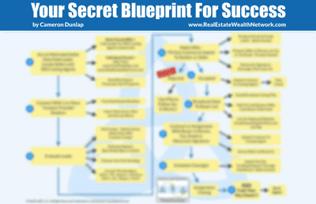

**>> Click here to get this blueprint now <<**

On my special training call today my special guest and I will be showing you how to use this blueprint to dominate your competition in 2020, plus you’ll learn:

* A tool you can use to quickly identify over **20 key motivational types** and find the **ultra-motivated sellers** through our proprietary “Stacking Method” in every market!
* How to leverage this **NEW intelligence-based technology** to work smarter (not harder)!
* How to get access to $1,000,000 **(you read that right, 1 million)** to fund an unlimited number of your deals *and we’ll explain why and how my special guest can do this and still stay in business.*
* A push button process for finding buyers who are flush with cash and how to identify the “super buyers” in any market!
* How to put the **3 fundamental tools** and the **3 necessities** a successful investor needs together (I call this the Real Estate Trifecta), because **when you do…the payout is HUGE!!**

Be one of the FIRST to access this brand new training below and blow your competition away in 2020!

>> Click here to join us now!

Regards,

{AFF NAME}

**Blueprint Email # 2 – IGNORE if not using blueprint.**

**Subj:**

Bad news ☹

Free Blueprint (disappearing soon)

**Body:**

Hey {frName},

First the good news:

You can still get a copy of this brand new Blueprint for Success and attend this powerful new training for FREE (while spots remain)…



**>> Snag your copy here before it’s too late <<**

**Now for the bad news:**

**This one of the last chances** you’ll have to attend this powerful training and **get in EARLY…before your competition does**…on this brand new intelligence-based investing system that allows you to easily identify all the ultra-motivated prospects for doing more deals that your heart (and bank account) desires, plus…

On Today’s call we’ll also cover…

* A tool you can use to quickly identify over **20 key motivational types** and find the **ultra-motivated sellers** through our proprietary “Stacking Method” in every market!
* How to leverage this **NEW intelligence-based technology** to work smarter (not harder)!
* How to get access to $1,000,000 **(you read that right, 1 million)** to fund an unlimited number of your deals *and we’ll explain why and how my special guest can do this and still stay in business.*
* A push button process for finding buyers who are flush with cash and how to identify the “super buyers” in any market!
* How to put the **3 fundamental tools** and the **3 necessities** a successful investor needs together (I call this the Real Estate Trifecta), because **when you do…the payout is HUGE!!**

>> Join us for this special training today (don’t miss out)!

At this very moment you have everything (and I mean everything) you need to successfully startup, run and be profitable right within your grasp… you just need to reach out and grab it.

Don’t let this opportunity pass you by.

The success that you desire deep down in your belly, YOU DESERVE IT, and I can this system was designed to help you achieve it.

I hope to see you on the call today

Regards,

{AFF NAME}

**Email – FAQ’s – For use with Attendee non-buyers**

**Subj:**

REI Trifecta (F.A.Q.’s & More)

**Body:**

Hey {FNAME},

….WOW!

The response to the release of Cameron’s brand new system, The REI Trifecta, has been very positive.

A bunch of excited folks jumped on board already and their early feedback has been phenomenal and for those that have gotten on board…**congratulations!!**

Over the last week or so we’ve also had a few really great questions come in so I went to Cam and asked him to take a moment to address the common questions here…

**REI Trifecta F.A.Q’s…**

**Q: I saw that Cam have a new system called The Motivated Seller Data Feed, is available on it's own?**

*A: I don’t blame you for being excited about The Motivated Seller Data Feed because it took us over 2 years to build and perfect this system. Right now the only way to get access to this system is inside the REI Trifecta.*

**Q: I see that the REI Trifecta gives me access to everything for a year, how much is it after the first year?**

*A: After your first year we do offer you the ability to renew for a discounted rate of $1,000, which gives you continued access to everything for another 12 months. There are no monthly fee’s.*

**Q: What’s the difference between the new REI Trifecta program and The Four Pillars of Real Estate program of the past?**

*A: The REI Trifecta is my newest and most powerful system for creating wealth through real estate. There are many differences including: Access to the Motivated Seller Data Feed, 150 skip trace searches, Inner Circle support, my proprietary Custom comps tool, access to 10 hours of trained VA services and more!*

>> Click here to see the presentation again and I’ll break it all down for you! (link to replay page)

**Q: Can I really do this without physically being in the area I invest in?**

*A: ABSOLUTELY! This system has been carefully created to give you all the tools you need to succeed. Plus…I include the Vacant House & foreclosure University to train you on the “How” to do all this from anywhere.*

*I am currently investing in multiple markets and so are MANY of my students. You can do it too and with the REI Trifecta it’s now easier than ever!*

**Q:I see your offering 10 hours of free VA services as a bonus with the REI Trifecta, what’s the cost after the free period?**

*A: Great question. We’ve been working closely with a third party VA company for the last 5 months (I’ve known the owner for years) as we trained their employees on our systems and processes so that you could use them to get the ball rolling if you needed help.*

*To be clear…This is NOT a profit center for us. If you wish to continue using the VA services it currently starts at $197/month. However, there is no contract and you can cancel them at anytime.*

*Also…Your time with the VA doesn’t start until you decide it does…so there’s nothing to worry about until you’ve decided to “press start” on their services.*

**Q: I really want to get on board and start doing deals with the REI Trifecta, but I can’t afford $1,497 today, what can I do?**

*A: Here’s some good news for you…it’s now easier than it’s ever been to get started with one of my programs! With the REI Trifecta we’re currently offering a 3-pay plan that allows you to get started with the entire system (EVEN my funding) for only $597!*

I hope these answer your most burning questions about Cam’s new program!

**…So, What’s Next?**

We’ll, I think you’ve got three good options…

**Option #1:** You’ve heard all you need to hear and you’re ready to get started now…

>> Click here now to see if we’re still accepting orders and reserve your spot today! (link to order page)

**Option #2:** You’re excited about the possibilities that will open up to you with access to the trifecta, but you’d like to see the presentation again…

>> Click here to attend our next available training! (link to replay page)

**Option #3:** You’ve got more questions…

Call Cam’s office at ***888-845-5219*** *anytime Monday – Friday form 8:30am – 8:00pm, we’re standing by and excited to help answer your questions.*

Regards,

{AFF NAME}